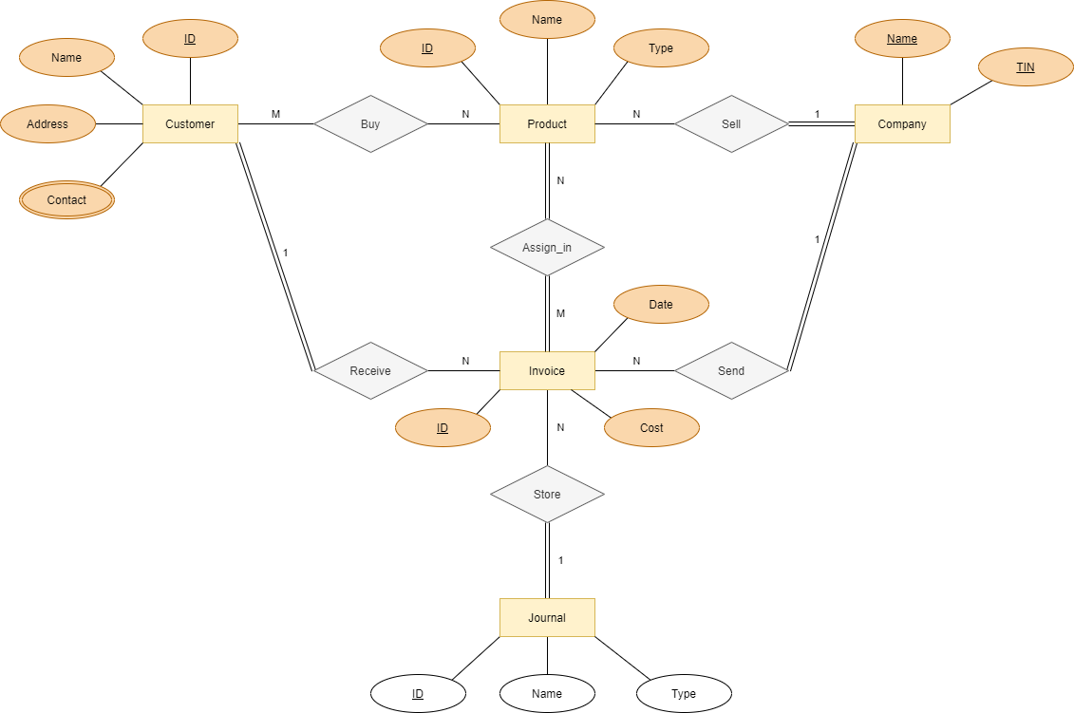Fig 1 ER Diagram

**Step 1: Mapping of Regular Entity Types.**

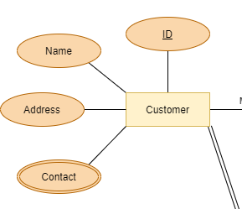 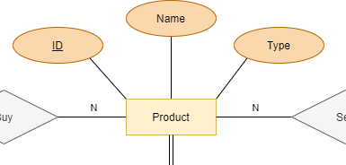

Fig 3 Product Entity

Fig 2 Customer Entity

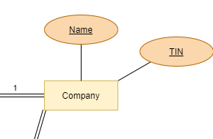 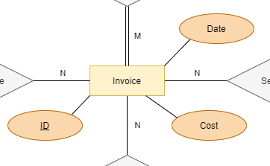

Fig 4 Company Entity

Fig 5 Invoice Entity

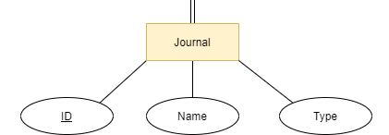

Journal Entity

Customer

|  |  |  |
| --- | --- | --- |
| cID | cName | Address |

Product

|  |  |  |
| --- | --- | --- |
| pID | pName | pType |

Company

|  |  |
| --- | --- |
| companyName | TIN |

Invoice

|  |  |  |
| --- | --- | --- |
| invoiceID | Cost | Date |

Journal

|  |  |  |
| --- | --- | --- |
| jID | jName | jType |

**Step 2 : Mapping of Weak Entity Types.**

None

**Step 3 : Mapping of Binary 1:1 Relation Types.**

None

**Step 4: Mapping of Binary 1:N Relationship Types.**

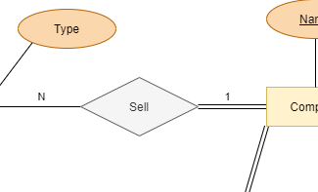

Sell Relationship

Product

|  |  |  |
| --- | --- | --- |
| pID | pName | pType |

|  |  |  |  |
| --- | --- | --- | --- |
| pID | pName | pType | TIN |

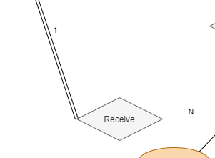

Receive Relation

Invoice

|  |  |  |
| --- | --- | --- |
| invoiceID | Cost | Date |

|  |  |  |  |
| --- | --- | --- | --- |
| invoiceID | Cost | Date | cID |

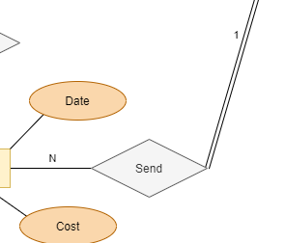

Send Relationship

Invoice

|  |  |  |  |
| --- | --- | --- | --- |
| invoiceID | Cost | Date | cID |

|  |  |  |  |  |
| --- | --- | --- | --- | --- |
| invoiceID | Cost | Date | cID | TIN |

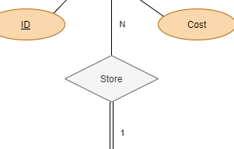

Store Relationship

Invoice

|  |  |  |  |  |
| --- | --- | --- | --- | --- |
| invoiceID | Cost | Date | cID | TIN |

|  |  |  |  |  |  |
| --- | --- | --- | --- | --- | --- |
| invoiceID | Cost | Date | cID | TIN | jID |

**Step 5: Mapping of Binary M:N Relationship Types.**

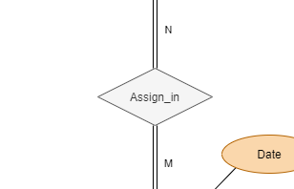

Assign_in Relationship

Assign_in

|  |  |
| --- | --- |
| pID | invoiceID |

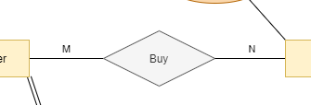

Buy Relationship

Buy

|  |  |
| --- | --- |
| cID | pID |

**Step 6: Mapping of Multivalued attributes.**

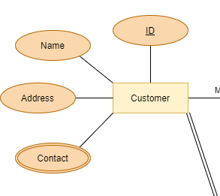

Contact Attribute

Contact

|  |  |
| --- | --- |
| cID | cContact |

**Step 7: Mapping of N-ary Relationship Types.**

None

**Step 8: Options for Mapping Specialization or Generalization.**

None

**Step 9: Mapping of Union Types (Categories).**

None

**Result of mapping ER schema into a relational database**

